

Abstract
This report examines the evolution of AIAG–VDA FMEA within BMW’s iFACTORY framework, where traditional risk assessment is enhanced by Computer Science and Artificial Intelligence. By 2025, BMW has integrated Machine Learning and Digital Twins to automate failure detection, reducing physical validation times from weeks to days. Leveraging Data Science pipelines and NVIDIA Omniverse, the methodology now predicts production deviations and optimizes software quality for the "Neue Klasse" fleet. This synergy creates a predictive, self-healing manufacturing environment that achieves near-zero defect rates through real-time AI-powered visual inspections.

report on Failure Mode and Effects Analysis (FMEA) Training
AIAG–VDA Harmonized PFMEA Methodology for Automotive Manufacturing – TV-435

By:
Aditya Kalidas
mail2adityakalidas@gmail.com
TABLE OF CONTENTS | Page No.
LIST OF FIGURES | 2
Introduction to FMEA | 3
History and Evolution of FMEA | 4
Types of FMEA | 5
The 7-Step Approach to PFMEA | 6
1. Planning and Preparation | 6
2. Structure Analysis | 6
3. Function Analysis | 7
4. Failure Analysis | 7
5. Risk Analysis and Action Priority | 8
6. Optimization | 9
7. Results Documentation | 9
PFMEA Inputs and Outputs | 10
Sample PFMEA – Car Door Assembly | 11
PFMEA Activity – Seat Assembly Scenario | 13
Do’s and Don’ts of FMEA | 14
Conclusion | 15

Report: Failure Mode and Effects Analysis (FMEA) Training – TV-435

1. Introduction
Failure Mode and Effects Analysis (FMEA) is a systematic methodology used to identify, evaluate, and mitigate potential failures in product design and manufacturing processes.
- Origin: Developed by the Verband der Automobilindustrie (VDA) in Germany.
- Purpose: Standardize risk assessment in automotive supply chains.
- Focus: Structured worksheets, Risk Priority Number (RPN), and later Action Priority (AP).
- Evolution: Harmonized AIAG–VDA FMEA introduced in 2019 to unify global practices.

2. History and Evolution
- 1940s: Originated with the US Military as a risk reduction tool.
- 1980s: Adopted by AIAG for automotive industries.
- 2019: Harmonized AIAG–VDA FMEA methodology introduced.
Key Approaches:
- AIAG FMEA – US automotive industry standard.
- VDA FMEA – German automotive industry standard.
- AIAG–VDA Harmonized FMEA – Unified global methodology.
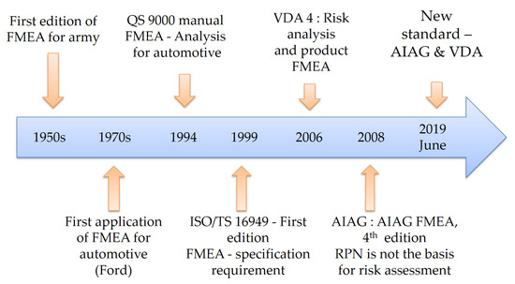

3. Types of FMEA
3.1 Process FMEA (PFMEA)
- Purpose: Analyze risks in manufacturing/assembly processes.
- Outcome: Reliable production processes, consistent quality output.
3.2 Design FMEA (DFMEA)
- Purpose: Identify risks in product design stage.
- Outcome: Robust designs meeting customer and safety requirements.

4. The 7-Step Approach (AIAG–VDA Harmonization)
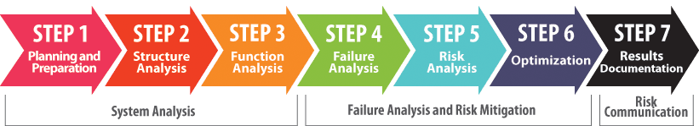
- Planning and Preparation :
  - The PFMEA study starts with a purposeful and careful definition of the scope.
  - The management team is responsible for setting the scope of the study.

- Structure Analysis – Break down process into steps, interfaces, and elements.
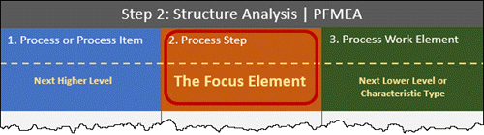
- Function Analysis : Define functions and requirements using tools like function trees and parameter diagrams. Think of the Function Analysis step as exploring what the product should be doing and what the overall process (and each of its steps) should be doing and how that functionality is facilitated.Using the Structure Analysis developed in Step 2, each element is analyzed separately in terms of its function(s) and corresponding requirement(s).
  - Tools:
    - Function analysis tree
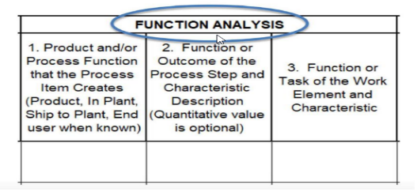
    - Parameter diagram

- Failure Analysis – Identify failure modes, effects, and causes (Failure Chain).
- Risk Analysis:
  - Evaluate S-O-D: Assess Severity, Occurrence, and Detection for each failure chain.
  - Use AP Tables: Determine Action Priority (High, Medium, Low) based on S-O-D combinations.
  - Purpose of AP: AP indicates priority for action—not risk level.
  - Required Actions:
  - High: Action or justification is mandatory.
  - Medium: Action or justification is recommended.
  - Low: Action is optional.
- Optimization – Develop actions to reduce risks and improve detection/prevention.
- Results Documentation – Summarize findings, actions, and alignment with team goals.

5. Risk Analysis – Action Priority (AP)
- High (H): Mandatory action or justification.
- Medium (M): Recommended action or justification.
- Low (L): Optional action.
Note: AP replaces RPN, emphasizing Severity > Occurrence > Detection.
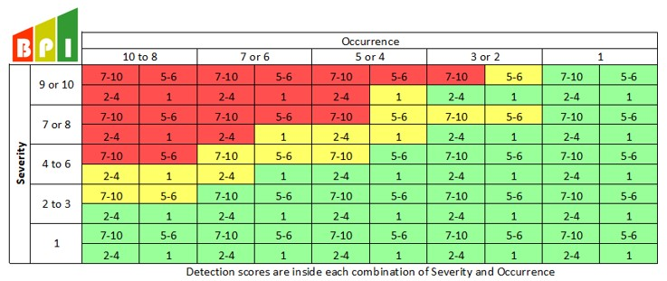

6. PFMEA Procedure
Inputs:
- Cause & Effect Matrix
- Process Map
- Process History
- Procedures, Knowledge, Experience
Outputs:
- List of preventive/detection actions
- History of actions taken
7.Sample PFMEA – Car Door Assembly

Table 1: Initial Risk Assessment
Process Step | Function / Requirement | Failure Mode | Effect of Failure | S | Cause of Failure | O | D | RPN | AP
Install Door Hinges | Ensure door opens/closes | Misaligned hinge | Door difficult to close | 7 | Improper positioning | 5 | 7 | 245 | High
Wiring Harness Routing | Electrical continuity | Harness pinched | Electrical short, window failure | 9 | Incorrect routing | 5 | 6 | 378 | High

Table 2: Recommended Actions
Process Step | Recommended Action | O | D | RPN | AP | Action Taken / Result
Install Door Hinges | Add jig, torque tool, training | 3 | 4 | 84 | Medium | Jig installed, torque tool added
Wiring Harness Routing | Routing guide, poka-yoke clips, edge protection | 1 | 1 | 9 | Low | Routing guide implemented, clips installed

8. PFMEA Activity – Seat Assembly Scenario
Reported Issues:
- Seat height adjustment lever jams.
- Airbag sensor gives false signals.
- Seat fabric wrinkles after installation.
Objective: Develop PFMEA worksheet in Excel for car seat assembly process.

9. Do’s and Don’ts of FMEA
Do’s:
- Perform as a team.
- Prioritize risks.
- Collect extensive data.
- Break analysis into smaller sections.
- Include diverse team members.
- Consider internal & external failures.
- Target Poka-Yoke solutions.
- Link FMEA with Control Plan.
Don’ts:
- Perform individually.
- Reduce risk without prioritization.
- Use incomplete or recent-only data.
- Analyze entire process in one take.
- Rely on generic actions (inspection, training) & maintain FMEA as standalone document.
10. Conclusion
In the modern industrial landscape, FMEA is evolving from a static document into a dynamic, data-driven engine. By integrating Computer Science principles, the methodology leverages automated workflows and digital twins to ensure software quality and system reliability.
The inclusion of Data Science allows for the analysis of vast historical process data, transforming the "Occurrence" and "Detection" rankings from subjective estimates into objective, evidence-based metrics. Furthermore, Machine Learning models can now predict potential failure modes before they occur by identifying patterns in sensor data and production telemetry. Ultimately, this synergy creates a "smart" FMEA framework where proactive risk mitigation is powered by real-time analytics, ensuring higher precision in quality engineering.

